Name: Quang Huynh

**Know Your Bones**

Part 1: *The Skeleton* Below is a diagram of the articulated skeleton in anatomical position. Identify all bones or groups of bones by writing the correct labels at the end of the lines. Then, select two different colors for the bones of the **axial** and **appendicular** skeletons and use them to color in the coding circles and corresponding structures in the diagram.

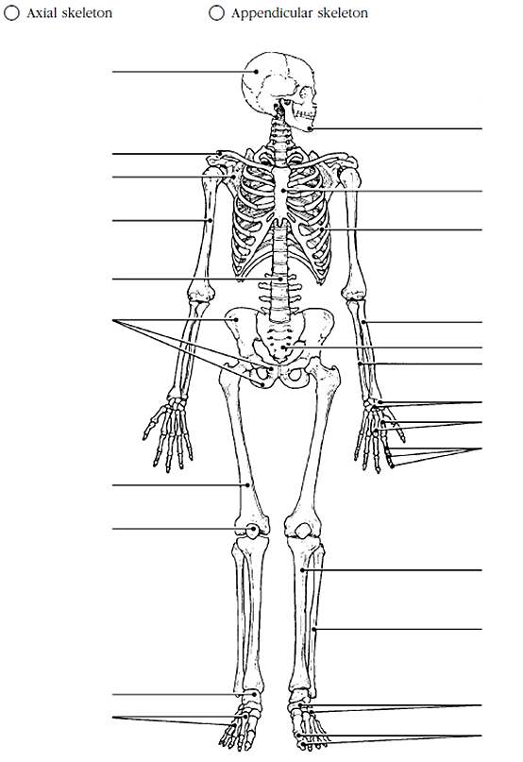



Cranium

Bone Bank

Fibula

Pelvic Bone

Tarsals

Patella

Ulna

Humerus

Carpals

Mandible

Vertebra

Tibia

Sternum

Scapula

Radius

Metacarpals

Clavicle

Rib

Cranium

Sacrum

Phalanges

Femur

Radius

Mandible



Clavicle



Scapula

Sternum



Humerous



Rib

Vertebra



Radius



Pelvic bone



Sacrum



Ulna



Carpals

Metacarpals



Phalanges



Femur



Patella

Tibia



Fibula



Calcaneus

Tarsals

Metatarsals

Phalanges

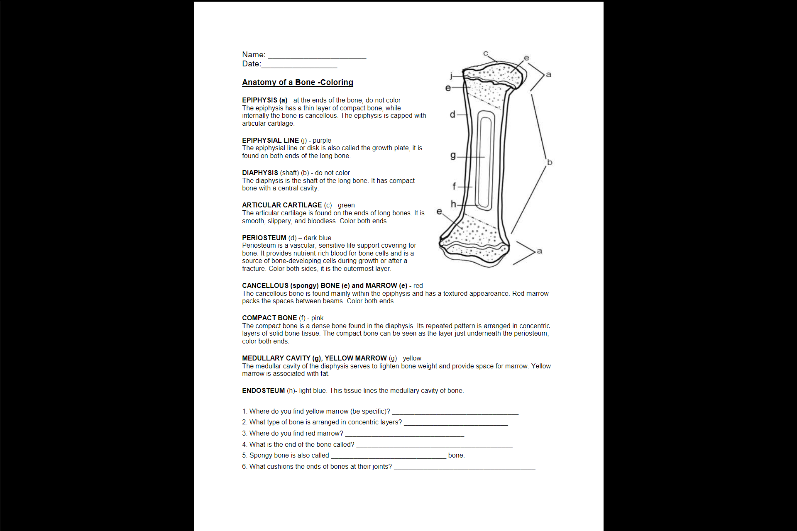

Articular cartilage

cancellous

Epiphysis

Compact bone

Compact bone

Medullary cavity; in the hollow interior of the middle of long bones

Part 2: *The Structure of a Bone* Identify and color the labeled parts of the bone below and answer the questions that follow.